Forum: General Assembly 2
Issue: Measures to contain the rising prevalence of measles globally
Student Officer: Eugene Shim
Position: Chair of General Assembly 2

Introduction
Measles is caused by a virus in the paramyxovirus family, which are tiny parasitic microbes, and is a extremely contagious respiratory disease and it’s normally passed by direct contact and by the air in the atmosphere. The cells of the virus invade the host cells and use cellular components to complete its life cycle. This infects the respiratory system, then impacts the whole body through the bloodstream. Measles can result in serious complications including pneumonia, seizures or even possibly death. Measles only occurs in humans.
Within 10-12 days of exposure to the virus, symptoms generally appear as a cough, fever, runny nose, red eyes, sore throat and white spots inside mouth. Skin rashes are observed when infected and this usually appears 14 days after infection and could stay up to 7 days. Mostly, the spread starts from head then slowly spreads all across the whole body. Complications are also likely to happen. Measles is seen in poorly nourished young children, especially with those who are lacking Vitamin A or whose immune systems have been weakened by suffering HIV or AIDs.
Measles is still a very common virus in developing countries (especially in Asia and Africa). According to the World Health Organization, more than 95% deaths caused by measles occur in countries with low per capita incomes and weak health infrastructures. In countries who are recovering from natural disasters or conflict, measles could be death threatening.
According to the Environmental Center in the United States, more than 140000 people have died from measles, with outranging numbers from children under the age of 5 in 2018. Adding on, in 2018 about 14% of the world’s children weren’t able to receive 1 dose of measles by their first birthday. Despite the fact that measles is death-threatening, not much action is being held globally.

Definition of Key Terms

Measles
Measles is the medical definition for rubeola (a highly infectious viral disease-causing fever and a red rash on the skin) and is most likely occurring in childhood.

Paramyxovirus
A family of single-stranded RNA viruses including viruses such as the parainfluenza viruses, the respiratory syncytial virus, and the biological pathogen that causes canine distemper, measles, mumps, Newcastle disease, and rinderpest.

Vaccination
To prevent a disease, the injection of a killed microbe in order to stimulate the immune system against the microbe which works by stimulating the natural disease-fighting system of the body.

Parasitic microbes
An organism that lives on or in a host organism and gets its food at the expense of its host

Complications
A secondary condition that develops in the course of primary disease of condition and arises as a result of it.

General Overview

Symptoms
The first sign of measles is usually shown as high fever, which is shown 10-12 days after exposure to measles and lasts 4-6 days. Different stages such as a runny nose, cough, red and watery eyes and small white spots inside the cheeks could develop as the initial stage of the virus. After several days, rash occurs mostly on the face and upper neck which lasts for 5-6 days then fades. Then, the person has the communicable period which is from 4 days before the rash appears until 4 days while rash is present.

Complications
Some patients who have suffered from measles may suffer from complications such as pneumonia and encephalitis. One of the most common complications is a bacterial ear infection. Adding on, 1 in 5 unvaccinated people who suffer measles get hospitalized in the United States. Additionally, 1 out of every 20 children with measles suffer from pneumonia which is the most common cause of death from measles.

People/groups at risk of measles complication
Measles can be severe in all age groups, however, can be most severe with children under the age of 5, adults older than age of 20, pregnant women, people with compromised immune systems such as from leukemia, AIDs or HIV infection.

Long term complications

Subacute sclerosing panencephalitis (SSPE) doesn’t happen very often, however a fatal disease of the central nervous system that results from measles infection acquired in early life.
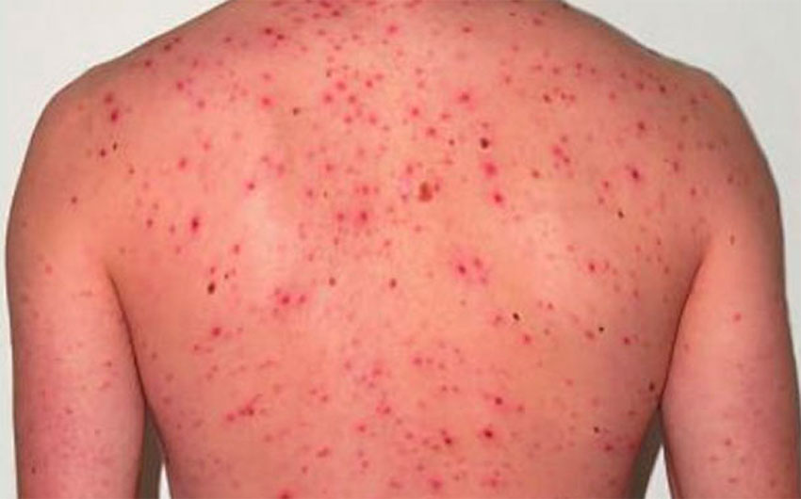

Figure 1: Back of a measles patient

Treatment

Currently, there isn’t a specific existing antiviral treatment for measles virus. Being different to bacterial infections, viral infections are not sensitive towards antibiotics. Severe complications from measles could be reduced through supportive care that ensures well balanced nutrition, adequate fluid intake and treatment of dehydration with World Health Organization’s (WHO) recommended solutions. These provided solutions replace fluids and other necessary elements that are lost through vomiting or diarrhea. This is done so that symptoms are relieved, and complications are addressed. Severe measles among children such as those who are hospitalized are treated with Vitamin A.

Vitamin A

All children with measles should receive 2 doses of Vitamin supplements, given 24 hours apart. Through this, children restore low vitamin A levels through suffocation of measles that occur even in well-nourished children and could prevent blindness and eye damage, which was shown to reduce the number of measles deaths.

Plenty of fluid and rest

When exposed to measles, doctors often recommend plenty of fluid (water) and rest. This is mainly because when affected to measles, a lot of fluid is lost through vomiting and diarrhea, so plenty of fluid needs to be supplied to the body. Resting is another essential treatment for measles to boost one’s immune system.

Prevention

Measles can be prevented through different ways. Vaccination is known as the best method to prevent measles. Isolation may be necessary since measles is a highly contagious disease.

According to WHO, vaccination prevented an estimated number of 23.2 million deaths from 2000 to 2018. However, in 2018 reported measles cases increased by 170% worldwide from 2016. 2 doses of the measles vaccine are 97% effective at preventing measles infection. There are 2 vaccinations available which are Measles Mumps Rubella (MMR) and Measles Mumps Rubella Varicella (MMRV). The MMR vaccination is a three in one vaccination which includes prevention towards measles, mumps and rubella. The MMRV vaccination includes MMR vaccine and vaccination for chickenpox as well.

Children receive their first vaccination at 12 months and their second dose between the age of 4 to 6. In addition, adults can request vaccination to doctors if they have not received one their whole life. Nearly all children got measles by the time they were 15 years old before vaccines were available. According to the Centers for disease control and prevention (CDC) it is estimated that 3 to 4 million people in the United States were infected each year before invention of vaccines. An estimated number of 400 to 500 people died, 48,000 were hospitalized, and 1,000 suffered encephalitis.

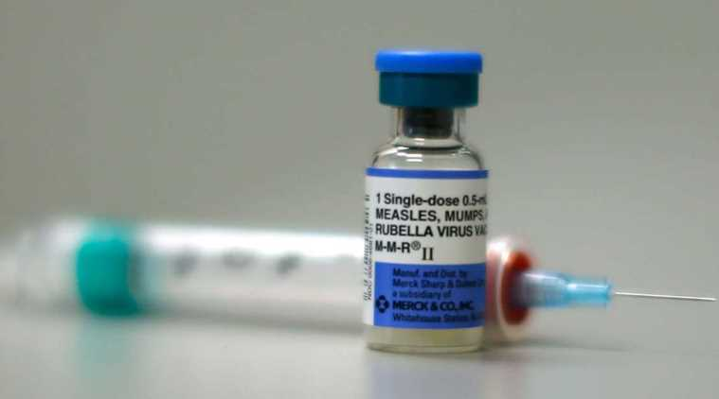

Figure 2: The MMR vaccine

Global impact/effect
According to CDC, 36 cases per 1 million persons are reported each year and around 134200 dies. For every 1000 children who get measles, 1 or 2 will die from it. Most will gain complications when infected. It is found that people who have measles feel more unwell than people with flu or chicken pox. People with measles reported that the infection had a large impact on their ability to perform their usual daily activities and caused high levels of pain and anxiety.

Rising of measles globally

Many countries around the world are experiencing measles outbreaks. As of 5 November 2019, there have been 413,308 confirmed cases reported by WHO through official monthly reporting by 187 Member States in 2019. According to WHO, different regions were seriously affected:

African region

Democratic republic of Congo (DRC): August 6th 2019: there were more than 140,000 suspected cases and more than 2,600 deaths reported. 2019’s identified cases exceeded the total reported for all in 2011 which was when DRC experienced a major outbreak.

Madagascar: August 7th 2019, more than 127000 suspected cases were recorded requiring additional medical care. Most age groups which were affected were between the age of 9 months and 9 years old.

Nigeria: June 14th 2019, more than 380000 suspected cases and 125 deaths have been reported across 715 local government areas in 36 states. Nigeria’s emergency operations center was activated in March 2019 as a response.

Region of Americas

South America: July 27th 2019, reported 1125 confirmed cases. Countries including Argentina, Brazil, Chile, Colombia, Peru, Uruguay and Venezuela were included. The outbreak started in Venezuela and was spread due to travelers.

United States: In 2018, 371 cases of measles were confirmed in the United States. From January to August 2019, 1215 cases across 30 states had been confirmed as measles by the Centers for Disease Control and Prevention

European region

Israel: July 30th 2019, 981 cases of measles were reported. Case numbers were lower than 2018 which recorded 3100 cases.

Ukraine: July 29th 2019, 56594 cases were reported. Ukraine already surpassed 54000 cases in 2018. Outbreak immunization activities have been implemented in Lviv and Vinnytsya. Additional immunization campaigns have been planned in the Khmelnytsky Region.

Western Pacific region

Philippines: At the end of June 2019, more than 2900 confirmed cases were reported from 17 different regions of the country. Around half of the cases were from below the age of 5.

South East Asian region

Thailand: around 4900 cases and vaccination campaign targeting children below 12 years old is ongoing. However, vaccination campaigns should be conducted for populations born between 1984 to 2000 as well as migrant populations in industrial areas, people participating in travel and tours company and such other establishments.

Myanmar: A nation-wide campaign is ongoing. Previously unreached adults should be vaccinated to stop the ongoing transmission currently.

Reasons of measles outbreaks

There are various causes or reasons for measle outbreaks including travelers, poor health services, civil strife, low awareness and so on.

Travelling between countries (through cough, sneeze or talks)

Increasing the number of people who contain measles travelling around the world could be a major reason for an epidemic. For example, United States experienced 17 outbreaks in 2018. Three outbreaks in New York City and New Jersey respectively contributed to most cases. It was mostly occurred between unvaccinated people in Orthodox Jewish communities which was associated with travelers who brought the virus from Israel, where a humongous outbreak was occurring. Around 80 people brought measles to the United States from other countries in 2018. This was the largestt number of imported cases since measles was 2000 when measles was eliminated in US.

Poor health services (low immunization rates)

Since measles is so contagious, it usually happens when there is a low immunization rate. Countries or regions who have less resources are more likely to suffer this disease. In these cases, the reason could be as simple as not living near doctors or health centers that offers the vaccine. According to the World Health Organisation (WHO), there have been more than 95% of deaths as a result of low-income countries with weak health infrastructures.

Civil strife

Countries who have experienced or are experiencing conflicts or natural disasters have a high possibility of measles outbreaks. The vaccination routine services get tangled when hospitals and health facilities are damaged or destroyed and individuals are unable to their jobs. Adding on, in crowded camps and settlements, diseases can very easily spread. For instance, in 2016, a year after the conflict in Yemen broke out, the rate of measles vaccination dropped hugely. In 2018, Yemen was one of the countries who had the highest number of cases in the world according to the United Nations Children’s Fund (UNICEF).

Low awareness

Communication and knowledge are essential for eradicating diseases. According to UNICEF, the measles vaccine is extremely safe and effective and has prevented 23.2 million deaths from 2000 to 2018. However, some people need more information on when, where, how and why their child should be vaccinated. They simply could be unaware of an outbreak or unclear on the importance of vaccines, or not informed of upcoming vaccination campaigns in their country.

UN Involvement, Relevant Resolutions, Treaties and Events
UN teams are out to help Samoa, a country who combats a deadly epidemic of measles. There have been 4200 cases, 62 deaths prompting authorities to declare a state of emergency on 15th November where they launched a massive vaccination 5 days later.
In August 2016, the UN foundation announced that the global health press fellowship would focus on emergency response to measles outbreaks. This was the opportunity for journalists to visit a country facing a disastrous measles outbreak and witness the immediate response of UN Agencies and ministries of health themselves. Those who were chosen for this fellowship got direct, unparalleled access to UN experts on the frontlines of the measles response, health workers, government leaders with in-country expertise.
UNICEF has supplied more than 200,000 vaccines for the campaign while WHO has brought in emergency medical staff from across the globe towards countries such as Venezuela.
In 2010, WHO established 3 milestones being 1) increase routine coverage with the first dose of measles-containing vaccine 2) reduce global annual measles incidence to less than 5 cases per million population 3) reduce global measles mortality by 95% from the 2000 estimate towards the future eradication of measles to be achieved by 2015.
WHO continued to strengthen the global laboratory network to ensure timely diagnosis of measles and track international spread of the measles viruses which allowed more coordinated countries to approach in targeting vaccination activities and reduce measles deaths from this vaccine-preventable disease.
In 2012, the Health Assembly endorsed the Global Vaccine Action Plan, with the objective of eliminating measles in four WHO regions by 2015 and in five regions by 2020 which were closer to a successful plan.
Medical centers for disease control and prevention provided both scientific and technical support to partners and countries in other parts of the world to prevent and reduce deaths caused by measles.

Timeline of Events
Date | Description of event
9th century | Persian doctor published one of the first written accounts of measles.
1757 | Scottish physician, Francis Home, proved that measles is caused by an infectious agent in the blood of patients.
1861 | During the first year of civil war, about 20,000 cases were reported in Union Soldiers with about 500 deaths.
1912 | Measles became a globally notifiable disease, especially in the United States requiring U.S. healthcare providers and laboratories to report all diagnosed cases. In the first 10 years of reporting, an average of 6,000 measles-related deaths were reported each year.
1958 | First measles vaccine is tested.
1963 | Measles vaccine licensed.
1971 | MMR vaccination debuts.
1978 | Measles targeted for elimination.
1981 | Low vaccination rates and measles cases drops dramatically.
2000 | Endemic measles eliminated from US.
2014 | A record year for measles in elimination era.
2017 | 35 measles deaths in Europe, thousands of cases.
2018 | Measles circulates in Venezuela again.
Between 2000-2018, measles vaccination resulted a 73% of deaths occurred by measles globally.
Even though a safe and cost-effective vaccine was available, in 2018, there were more than 140 000 measles deaths globally, mostly between children under the age of five.
353,236 measles cases were reported to WHO.

Possible Solutions
Firstly, in order to prevent measles spreading across globally, with the support of WHO and United Nations, nations should ensure citizens receive vaccination at the correct age which is the best method available currently. There is no exact treatment developed for measles currently therefore making vaccination the best method. Moreover, nations should maintain high measles vaccination coverage.

Secondly, with the help of non-governmental organizations (NGOs), UN and WHO, using both scientific and technological skills, nations must gather appropriate skillful individuals such as doctors and scientists to develop exact treatment after one has been infected by measles. Adding on, enough material that those individuals need should be provided so that investigation could be successful. This investigation should be done as soon as possible since there are no exact treatments developed or found for measles currently.

Thirdly, in immigration procedures of travelers globally, nations are encouraged to build systems which allow checking if passengers are infected to measles or not. If they are, ensure they are sent to hospitals and are separated from other passengers.

Fourthly, nations, especially those who are less developed should ensure that people have adequate amount of Vitamin A provided if necessary and area of high sanitation. Adding on, local doctors and hospitals should make sure the infected patient is totally isolated so that there is no contact with others since measles is a highly contagious virus.

Lastly, awareness should be raised so that fund raising can happen for needed countries from the more economically developed countries towards children who need vaccination cooperating with WHO and UNICEF. People should know the seriousness of this disease by giving support.

Bibliography
“Global Health - Newsroom - Measles.” Centers for Disease Control and Prevention, Centers for Disease Control and Prevention, 12 Dec. 2019,
https://www.cdc.gov/globalhealth/newsroom/topics/measles/index.html
Higuera, Valencia. “Measles: Symptoms, Diagnosis, and Treatments.” Healthline, Healthline Media, 21 Aug. 2019,
https://www.healthline.com/health/measles#pictures

“Measles Complications.” Centers for Disease Control and Prevention, Centers for Disease Control and Prevention, 13 June 2019,
“Measles.” Mayo Clinic, Mayo Foundation for Medical Education and Research, 24 May 2019,
https://www.mayoclinic.org/diseases-conditions/measles/symptoms-causes/syc-20374857“
“Measles.” National Foundation for Infectious Diseases, 18 Dec. 2019,
https://www.nfid.org/infectious-diseases/measles/
https://www.cdc.gov/measles/symptoms/complications.html
“Measles.” World Health Organization, World Health Organization,
https://www.who.int/news-room/fact-sheets/detail/measles
UN Team Aids Samoa Response to Deadly Measles Epidemic | UN News.”
https://news.un.org/en/story/2019/12/1052881

